1. Prototyping:
   1. Introduction:

At prototyping phase, multiple amplifiers are to be tested and compared with each other. For each of these tests, a small PCB with pre-defined inputs and outputs is to be printed. On the main PCB, there is a pre-defined socket / header for this small amplifier test PCB. This accelerates prototyping phase and saves money.

* 1. Amplifier’s pre-defined block diagram:

GND

+3.3V

Output (3-pins)

Thermocouple

Ctrl (3-pins)

Amp. Circuit

* 1. Amplifier’s pre-defined input / output header position:

+3.3V

OUT3

OUT2

OUT1

GND

CTRL3

CTRL2

CTRL1

TC-

TC+

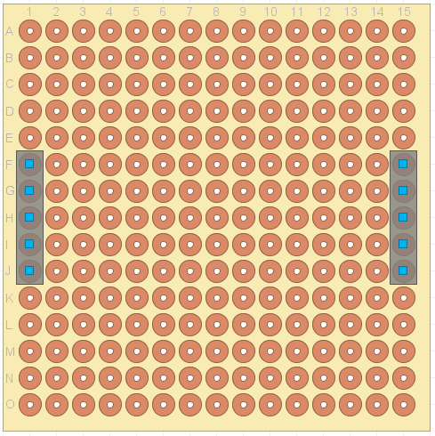

1. Tested amplifiers:
   1. Single BJT transistor amplifier:

Using BC337 BJT NPN transistor, the following circuit is implemented:

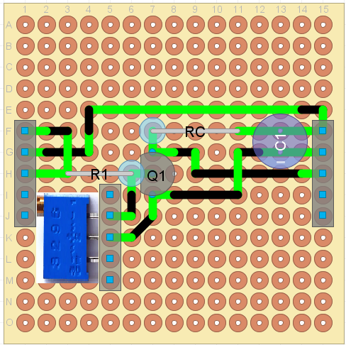add real image here too!